There is a robot on an m x n grid. The robot is initially located at the **top-left corner** (i.e., grid[0][0]). The robot tries to move to the **bottom-right corner** (i.e., grid[m - 1][n - 1]). The robot can only move either down or right at any point in time.

Given the two integers m and n, return *the number of possible unique paths that the robot can take to reach the bottom-right corner*.

The test cases are generated so that the answer will be less than or equal to 2 * 109.

**Example 1:**

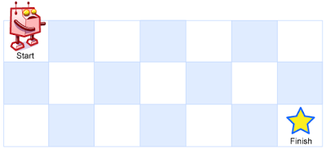

Input: m = 3, n = 7  
Output: 28

**Example 2:**

Input: m = 3, n = 2  
Output: 3  
Explanation: From the top-left corner, there are a total of 3 ways to reach the bottom-right corner:  
1. Right -> Down -> Down  
2. Down -> Down -> Right  
3. Down -> Right -> Down

**Constraints:**

* 1 <= m, n <= 100